

**LG TS-186KAA7 (1.5 Ton)**

**Rs. 55,500/-**

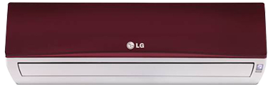

**Product Features**

* power mode
* precise system control technology
* concealed LED display
* Intelligent airflow
* precise system control technology

**Specification**

**Type** Wall Mounted Split AC

**Cooling (Btu/h)** 48000

**Voltage (V)** 220-240

**Power Input (W)** 3400

**EER (Btu/W-h-W/W)** 5.1-3.75